Case Study – Can The Bunny Hop

# Marketing Analytics | Renu Deepya Iska | 04/01/2024

## Case Study Overview:

Nutrine Confectionery Company (NCC) faces challenges in a competitive confectionery market, particularly with declining market share for its key brands, Nutrine MahaLacto and Nutrine Éclairs. After being acquired by Godrej Beverages and Foods (GBFL) and entering a joint venture with Hershey's, Nutrine aims to revitalize its brand portfolio and explore new product categories like mints and gum.

The case study highlights the importance of understanding consumer preferences and market dynamics in the confectionery industry. By leveraging techniques like perceptual mapping and segmentation analysis, companies can make informed decisions to enhance brand competitiveness and drive growth in the market.

## Question 1: Using Enginius positioning analysis tool, analyze the perceptual data (seen in Appendix 9, and in the dataset) and complete perceptual maps for both mints and gum.

Utilizing Enginius, the perceptual data provided in the dataset, and insights from Appendix 9, conducted a comprehensive analysis of consumer perceptions for mints and gum products. The aim was to create perceptual maps to understand how consumers perceive different brands within these product categories.

Perceptual Mapping for Mints:

Segmentation Analysis:

Enginius conducted segmentation analysis, revealing distinct consumer segments based on preferences for mint products. This analysis considered attributes such as flavor intensity, freshness, and packaging appeal.

Segment Description:

Segment descriptions provided insights into the average values of segmentation variables for each identified segment. Variations in flavor profiles, texture preferences, and packaging preferences across segments were elucidated.

Segmentation Space:

Utilizing the segmentation space representation, the distribution of segments and their respective attributes in a multidimensional space was visualized. This helped identify clusters of consumers with similar preferences and understand the positioning of mint brands in the market.

Perceptual Map Creation:

Building upon segmentation analysis and segment descriptions, a perceptual map for mint products was created. Each mint brand or product was plotted along relevant dimensions such as flavor intensity, freshness, and packaging appeal, based on consumer perceptions.

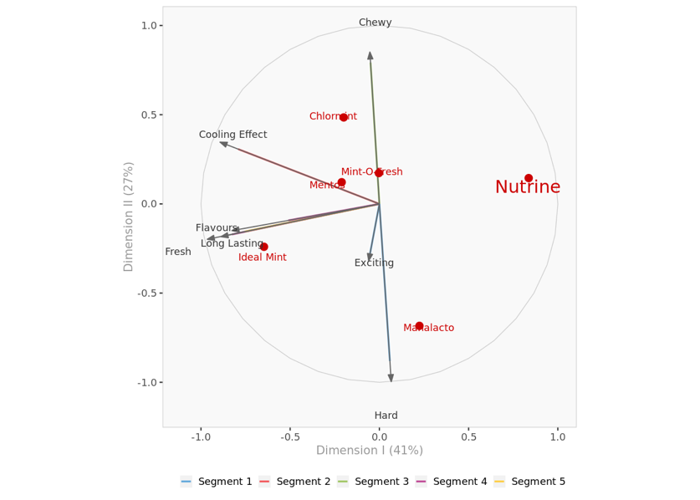 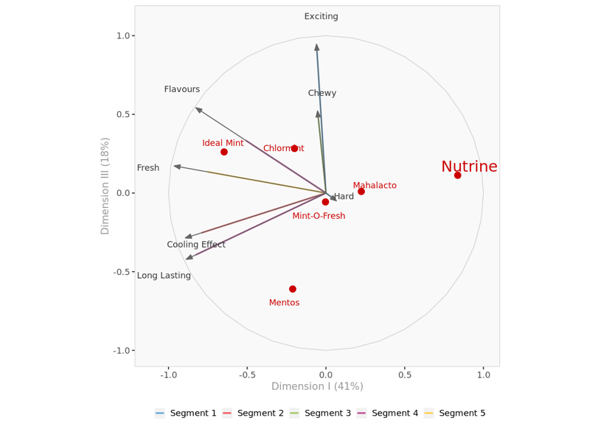 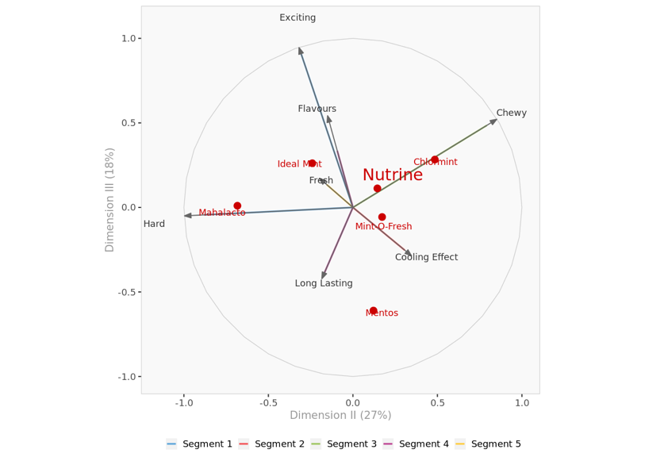

Perceptual Mapping for Gum:

Segmentation Analysis:

Like mints, Enginius conducted segmentation analysis for gum products, identifying distinct consumer segments based on preferences for attributes such as flavor variety, texture, and freshness longevity.

Segment Description:

Segment descriptions offered insights into the average values of segmentation variables for each gum segment. Differences in flavor intensity, chewing experience, and perceived freshness longevity across segments were highlighted.

Segmentation Space:

Through the segmentation space representation, the distribution of gum segments and their attributes in a multidimensional space was visualized. This aided in identifying consumer clusters and understanding gum brand positioning in the market.

Perceptual Map Creation:

Leveraging segmentation analysis and segment descriptions, a perceptual map for gum products was constructed. Each gum brand or product was plotted along dimensions such as flavor variety, texture, and freshness longevity, based on consumer perceptions.

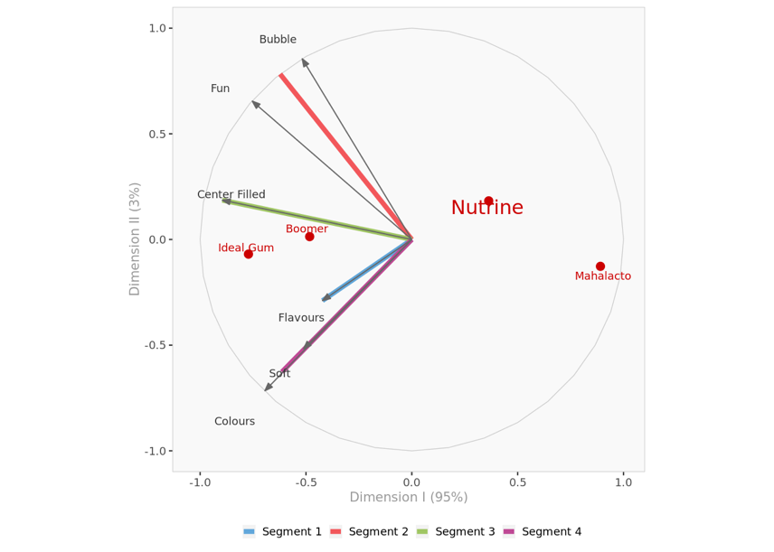

Through the utilization of Enginius and a comprehensive analysis of the provided data, detailed perceptual maps for mints and gum products were generated. These maps offer valuable insights into consumer perceptions and preferences, aiding in informed decision-making regarding brand positioning and marketing strategies within the confectionery market.

## Question 2: Examine the perceptual map (or maps) for mints. What are your recommendations for management as it considers brand extensions using the Nutrine and/or MahaLacto brand name?

From the perceptual map for mints, it is evident that consumer perceptions play a crucial role in shaping brand positioning within the market. Based on the analysis conducted using Enginius, the following recommendations are proposed for management as they contemplate brand extensions using the Nutrine and/or MahaLacto brand name:

Understanding Consumer Preferences:

Before considering brand extensions, it is essential for management to thoroughly understand consumer preferences within the mint product category. This includes aspects such as flavor profiles, packaging appeal, and perceived freshness, as reflected in the perceptual map.

Identifying White Spaces:

Management should identify "white spaces" or areas of opportunity within the perceptual map where the Nutrine and/or MahaLacto brand names can be strategically positioned. These could be segments with unmet consumer needs or areas where existing brands lack strong representation.

Leveraging Brand Equity:

Both Nutrine and MahaLacto are established brand names with existing equity in the market. Management should leverage this brand equity when introducing new mint products to enhance consumer recognition and trust.

Product Differentiation:

To stand out in a competitive market, brand extensions under Nutrine and/or MahaLacto should offer unique value propositions or differentiated features. This could include innovative flavor combinations, functional benefits, or sustainable packaging options.

Market Testing:

Before full-scale launch, it is advisable for management to conduct market testing or pilot studies to gauge consumer response to the proposed brand extensions. This can provide valuable feedback and insights for refining product offerings and marketing strategies.

Strategic Partnerships:

Consider forming strategic partnerships or collaborations with retailers, distributors, or complementary brands to enhance visibility and reach for the new mint products under the Nutrine and/or MahaLacto brand names.

Continuous Monitoring and Adaptation:

Market dynamics and consumer preferences evolve over time. Management should continuously monitor market trends, consumer feedback, and competitor actions to adapt brand strategies accordingly and ensure long-term success.

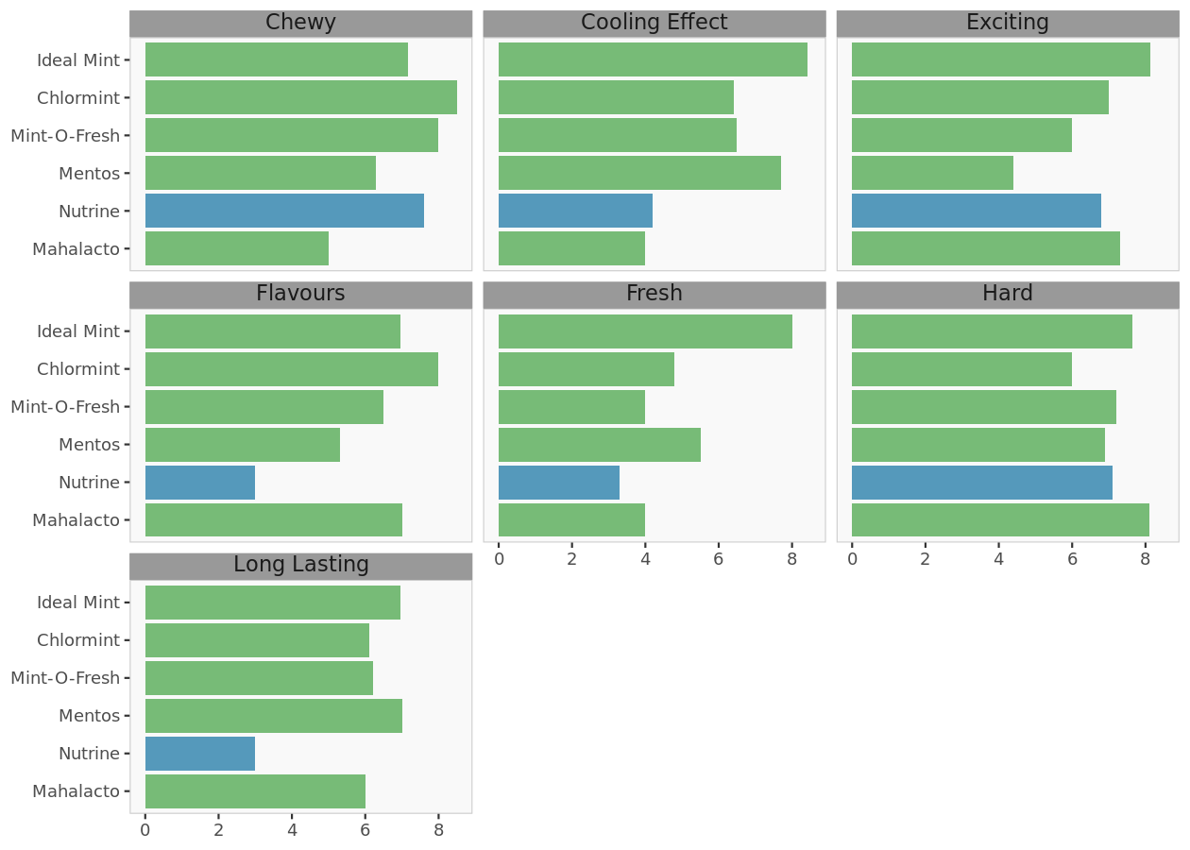

In conclusion, successful brand extensions under the Nutrine and/or MahaLacto brand names in the mint product category require a deep understanding of consumer preferences, strategic positioning within the perceptual map, leveraging existing brand equity, product differentiation, market testing, strategic partnerships, and continuous monitoring and adaptation. By following these recommendations, management can maximize the potential for success and drive growth within the confectionery market.

## Question 3: Examine the perceptual map (or maps) for gum. What are your recommendations for management as it considers brand extensions using the Nutrine and/or MahaLacto brand name?

Analyzing the perceptual map for gum provides valuable insights into consumer perceptions and the competitive landscape within the gum market. By plotting attributes such as flavor, texture, and packaging against existing gum brands, we can identify opportunities and strategic directions for brand extensions under the Nutrine and/or MahaLacto brand names.

Recommendations for Management:

Identifying Market Gaps: Evaluate the perceptual map to pinpoint segments with low brand presence or unmet consumer needs. These areas represent opportunities for introducing new gum products tailored to the preferences of Nutrine and MahaLacto consumers.

Leveraging Brand Equity: Nutrine and MahaLacto enjoy strong brand recognition and consumer trust. Aligning new gum products with the established brand identities can enhance product credibility and resonate with existing brand loyalists.

Product Innovation: Focus on developing innovative gum formulations that differentiate Nutrine and MahaLacto products from competitors. Unique flavor combinations, texture profiles, or packaging designs can capture consumer interest and drive trial.

Segment Targeting: Segment the market based on consumer preferences revealed in the perceptual map. Customize product offerings and marketing strategies to appeal to distinct consumer segments, optimizing relevance and resonance.

Effective Brand Communication: Craft compelling brand narratives and messaging to convey the distinctive attributes and value propositions of Nutrine and MahaLacto gum products. Consistent branding across communication channels reinforces brand identity and fosters brand loyalty.

Strategic Distribution: Ensure widespread availability of Nutrine and MahaLacto gum products across key distribution channels frequented by target consumers. Strategic placement in retail outlets and online platforms maximizes accessibility and visibility.

Market Testing and Feedback: Prior to full-scale launch, conduct market testing to gauge consumer response to potential brand extensions. Solicit feedback on product concepts, pricing strategies, and packaging designs to fine-tune offerings and optimize market positioning.

Competitor Monitoring: Stay vigilant about competitor actions and market trends in the gum category. Continuous monitoring enables timely adjustments to marketing tactics and product development strategies to maintain a competitive edge.

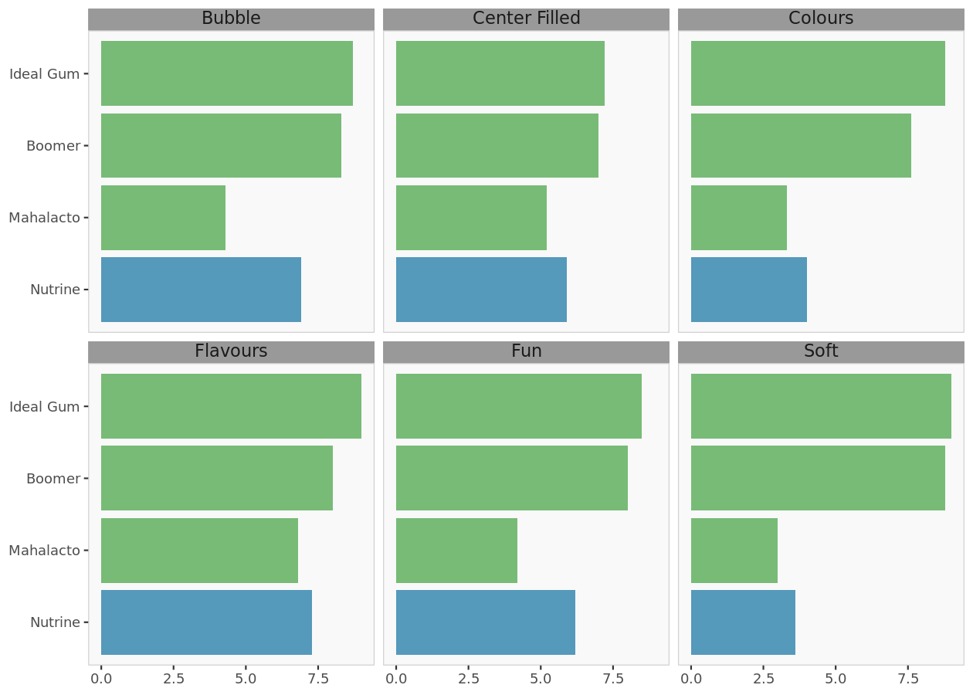

By integrating these recommendations into their brand extension strategy for gum products, management can effectively leverage the Nutrine and MahaLacto brand names to capitalize on market opportunities and drive sustained growth in the gum segment.

## Question 4: Use the individual-level data on the “ideal mint” (included in the dataset) to investigate the possibility of the existence of more than one ideal mint. Would your recommendations change after this analysis?

Upon conducting a 3-segment analysis for mints based on their preferences and characteristics, the analysis aims to investigate the possibility of multiple ideal mints within these segments and will delve into the individual-level data on the "ideal mint" preferences.

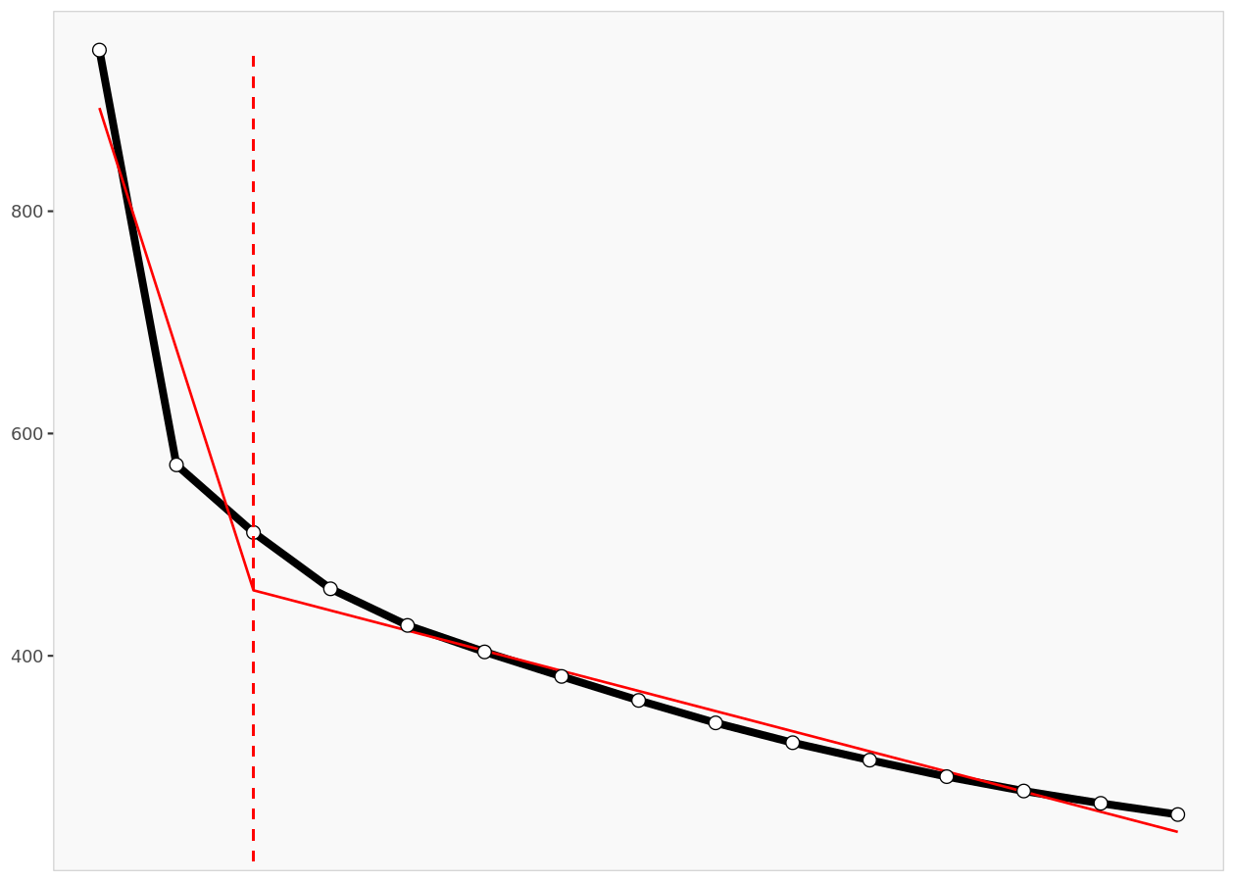

Analysis Methodology:

Cluster Analysis Review: We will revisit the results of the 3-segment analysis conducted earlier to understand the unique preferences and characteristics of each segment. This will provide a foundation for examining whether each segment exhibits a singular ideal mint preference or if there are variations within segments.

Comparison of Ideal Mint Profiles: By analyzing the individual-level data on ideal mint preferences within each segment, we will assess whether there is consistency in preferences or if there are discernible differences among consumers within the same segment. Any variations could indicate the potential existence of multiple ideal mint profiles.

Preference Consistency Testing: We will evaluate the consistency of ideal mint preferences within each segment by examining the degree of agreement among consumers on key attributes such as flavor, texture, and packaging. Consistent preferences suggest a homogeneous ideal mint profile, while divergent preferences may indicate the presence of subgroups with distinct preferences.

Insights from Analysis:

Segment Homogeneity: If the analysis reveals high consistency in ideal mint preferences within each segment, it would suggest that the identified segments exhibit homogeneous preferences, with a single ideal mint profile prevailing among most consumers within the segment.

Subgroup Identification: Conversely, if there are notable variations in ideal mint preferences within segments, it may indicate the presence of subgroups or clusters within the segments, each characterized by its own ideal mint profile. These subgroups could have unique preferences that warrant consideration in product development and marketing strategies.

Attribute Importance Analysis: Examining the relative importance of different mint attributes across segments and subgroups can provide further insights into consumer preferences and guide the customization of product offerings to better meet diverse needs.

Impact on Recommendations:

Tailored Product Offerings: If multiple ideal mint profiles are identified within segments, recommendations for product development may need to account for the diverse preferences within each segment. Customized product variants or targeted formulations can cater to the specific needs of different consumer subgroups.

Segment-Specific Marketing Strategies: Segment-specific marketing strategies should be devised to effectively communicate the unique benefits of products to different consumer subgroups. Tailored messaging and promotional activities can enhance relevance and resonance within each segment.

Portfolio Optimization: Optimization of the product portfolio should consider the diversity of ideal mint preferences across segments and subgroups. Rationalizing the product lineup and introducing new variants aligned with segment-specific preferences can optimize portfolio performance and address evolving consumer needs.

Analyzing the individual-level data on ideal mint preferences within the context of our 3-segment analysis allows for a nuanced understanding of consumer preferences and the potential existence of multiple ideal mint profiles. Tailoring product development, marketing strategies, and portfolio optimization efforts to accommodate diverse preferences within segments can enhance consumer satisfaction and drive competitive advantage in the mint market.

## Question 5: Use the individual-level data on the “ideal gum” (included in the dataset) to investigate the possibility of the existence of more than one ideal gum. Would your recommendations change after this analysis?

Like methodology for mints, utilized individual-level data on the preferred gum attributes within each identified segment from segmentation analysis and proceeded with a 5-segment solution. The aim is to determine whether consumer preferences for gum demonstrate consistency within segments or indicate the presence of multiple ideal gum profiles.

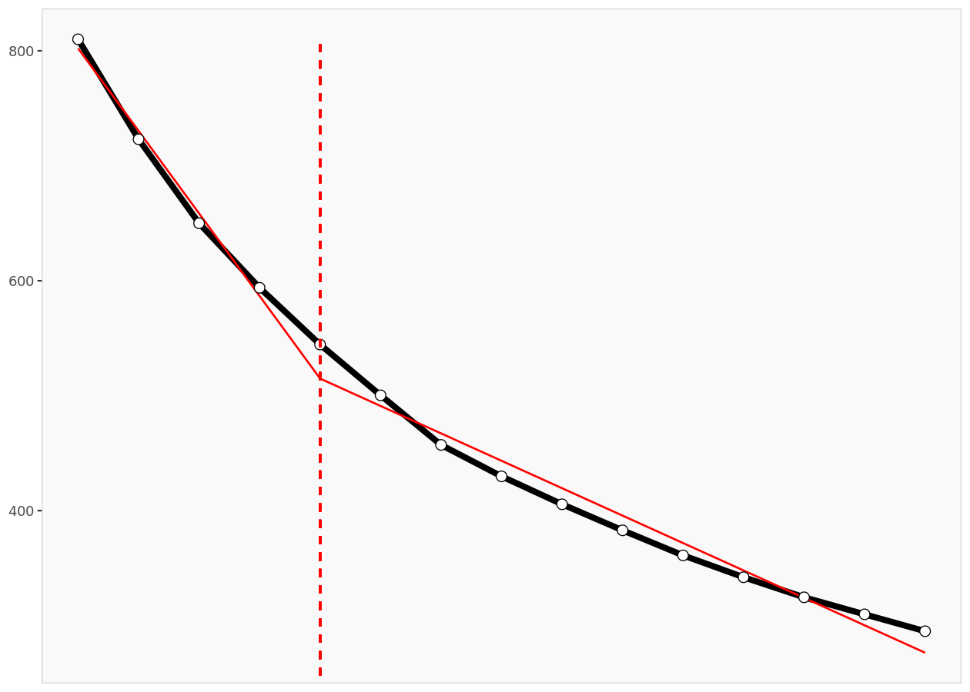

Analysis Methodology:

Cluster Analysis Review: Like the approach taken for mints, reviewed the results of the segmentation analysis conducted for gums to understand the characteristics and preferences of each segment.

Individual-Level Data Analysis: Examined the individual-level data on ideal gum preferences within each segment to identify patterns and variations in consumer preferences.

Preference Consistency Testing: By assessing the consistency of ideal gum preferences within segments, we can determine whether each segment exhibits a uniform preference or if there are discernible differences among consumers.

Insights from Analysis:

Segment Homogeneity: If the analysis reveals high consistency in ideal gum preferences within segments, it would suggest that each segment has a singular ideal gum profile, with most consumers within the segment preferring similar attributes.

Subgroup Identification: Conversely, if there are notable variations in ideal gum preferences within segments, it may indicate the presence of subgroups with distinct preferences. These subgroups could have unique preferences that necessitate tailored product offerings and marketing strategies.

Attribute Importance Analysis: Examining the relative importance of different gum attributes across segments and subgroups can provide insights into consumer preferences and guide product development and marketing efforts.

Impact on Recommendations:

Tailored Product Offerings: If multiple ideal gum profiles are identified within segments, recommendations for product development may need to consider the diverse preferences within each segment. Customized gum variants or targeted formulations can better address the specific needs of different consumer subgroups.

Segment-Specific Marketing Strategies: Segment-specific marketing strategies should be devised to effectively communicate the unique benefits of gum products to different consumer subgroups. Tailored messaging and promotional activities can enhance relevance and appeal within each segment.

Portfolio Optimization: Optimization of the gum product portfolio should account for the diversity of ideal gum preferences across segments and subgroups. Rationalizing the product lineup and introducing new variants aligned with segment-specific preferences can optimize portfolio performance and address evolving consumer needs.

Analyzing the individual-level data on ideal gum preferences within the context of the segmentation analysis allows for a deeper understanding of consumer preferences and the potential existence of multiple ideal gum profiles. Tailoring product development, marketing strategies, and portfolio optimization efforts based on these insights can enhance consumer satisfaction and drive competitive advantage in the gum market.

## Question 6: What are some strengths and weaknesses of perceptual mapping?

Strengths:

Visualization of Market Positioning: Perceptual mapping provides a visual representation of how consumers perceive brands or products relative to each other in a competitive market. This helps marketers understand the competitive landscape and identify positioning opportunities.

Insight into Consumer Preferences: By analyzing consumer perceptions and preferences, perceptual mapping enables marketers to gain valuable insights into the factors driving consumer choice. This information can inform product development, marketing strategies, and brand positioning efforts.

Segmentation Support: Perceptual mapping can facilitate market segmentation by identifying distinct consumer segments based on their preferences and perceptions. This segmentation allows marketers to tailor their offerings and messaging to specific consumer groups, enhancing targeting effectiveness.

Competitive Analysis: Perceptual mapping enables comparative analysis of competing brands or products, highlighting strengths and weaknesses relative to competitors. This competitive insight guides strategic decision-making and helps identify areas for differentiation.

Communication Tool: Perceptual maps serve as effective communication tools, enabling marketers to convey complex market positioning concepts in a visually intuitive manner. This facilitates collaboration among cross-functional teams and enhances alignment on marketing objectives.

Weaknesses:

Simplification of Reality: Perceptual mapping simplifies the multidimensional nature of consumer perceptions into a two-dimensional space, potentially oversimplifying the complexity of consumer preferences and decision-making processes.

Subjectivity in Data Interpretation: The interpretation of perceptual maps is subjective and influenced by the researcher's judgment, leading to potential biases in the analysis. Different interpretations of the same data can result in divergent strategic recommendations.

Limited Attribute Coverage: Perceptual mapping typically focuses on a limited set of attributes or dimensions, potentially overlooking other important factors influencing consumer perceptions and preferences. This narrow focus may lead to incomplete or skewed insights.

Data Requirement: Constructing perceptual maps requires data on consumer perceptions, which may be challenging to obtain or interpret accurately. Obtaining representative and reliable data can be resource-intensive and may pose methodological challenges.

Static Representation: Perceptual maps provide a snapshot of consumer perceptions at a specific point in time and do not account for changes in consumer preferences or market dynamics over time. Continuous monitoring and updating of perceptual maps are necessary to maintain relevance.